1. **Search context is the root interface in Selenium.**
2. **Web river interface extends the Search context interface.**
3. **And Remote Web driver class implements Web driver interface, JavaScript executor interface and Take screenshot Interface.**
4. **Chromium driver class extends Remote Web driver class.**
5. **And Chrome driver class extends Chromium driver class**
6. **And Edge class extends Chromium driver.**
7. **And Safari class extends Remote web driver class.**
8. **And Firefox class extends. Remote Web driver class.**

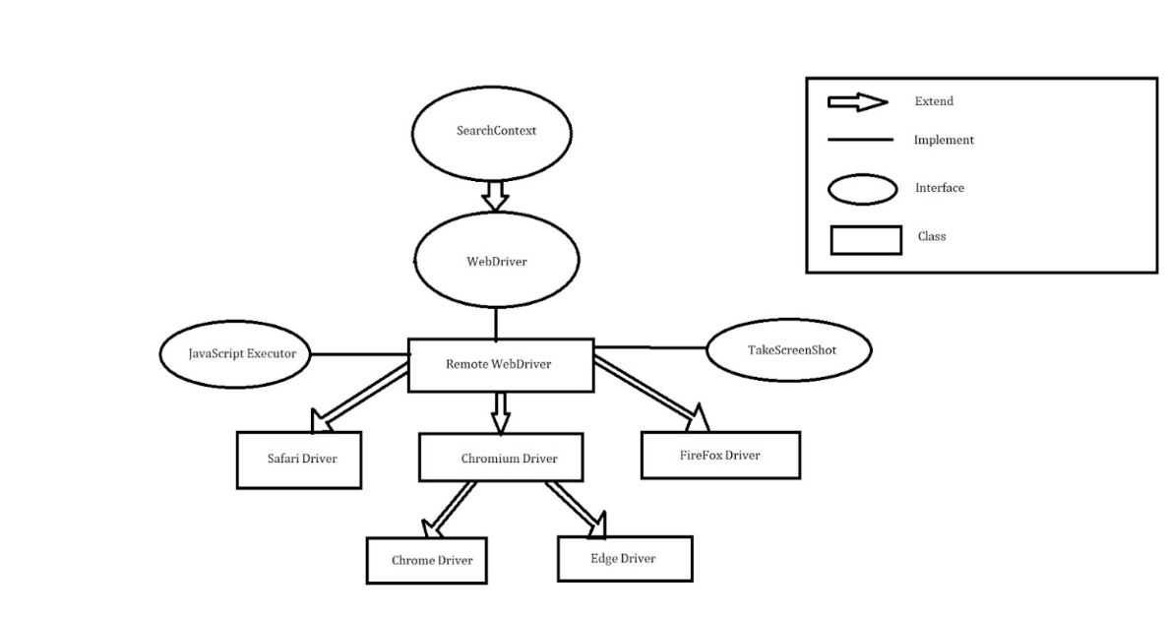

**public** **interface** SearchContext {}

**public** **interface** WebDriver **extends** SearchContext

{}

**public** **class** RemoteWebDriver

**implements** WebDriver,

JavascriptExecutor

TakesScreenshot {

}

**public** **class** ChromeDriver **extends** ChromiumDriver {

**}**

**public** **class** EdgeDriver **extends** ChromiumDriver {

}

**public** **class** ChromiumDriver **extends** RemoteWebDriver

{

}

**public** **class** FirefoxDriver **extends** RemoteWebDriver

**public** **class** SafariDriver **extends** RemoteWebDriver

**Search context interface two abstract methods as**

* **find element and**
* **find elements methods**

**Web driver interface contains various methods as**

* **Get method**
* **getCurrentUrl method**
* **getTitle method**
* **getPageSource method**
* **close method**
* **quit method**
* **getWindowHandles method**
* **getWindowHandle method**
* **switchTo method**
* **navigate method**
* **manage method**
* **interface** Options {

**void** addCookie(Cookie cookie);

**void** deleteCookieNamed(String name);

**void** deleteCookie(Cookie cookie);

**void** deleteAllCookies();

Set<Cookie> getCookies();

Cookie getCookieNamed(String name);

Timeouts timeouts();

Window window();

Logs logs();

}

**interface** Window {

Dimension getSize();

**void** setSize(Dimension targetSize);

Point getPosition();

**void** setPosition(Point targetPosition);

**void** maximize();

**void** minimize();

**void** fullscreen();

}

**interface** Navigation {

**void** back();

**void** forward();

**void** to(String url);

**void** to(URL url);

**void** refresh();

}

**interface** Options {

**void** addCookie(Cookie cookie);

**void** deleteCookieNamed(String name);

**void** deleteCookie(Cookie cookie);

**void** deleteAllCookies();

Set<Cookie> getCookies();

Cookie getCookieNamed(String name);

Timeouts timeouts();

Window window();

Logs logs();

}

**interface** Timeouts {